**Ecco Restaurant Marketing Analysis**

Kaushik Suresh

June, 2021

1. **Introduction**
   1. **Background**

Food in New York is always mesmerizing. One such great place in New York would definitely be the Ecco Restaurant. Ecco is an upscale Italian Restaurant with traditional homestyle cooking. We have been serving Tribeca for over 3 decades, with consistently authentic dishes that are all prepared to order. It was located in 124 Chambers St, New York, NY 10007, United States and due to unforeseen circumstances the establishment was closed. After a lot of thought and hard work the Ecco management have given a thought to restart their business in the same exact location where they have been serving their authentic dishes for the past three decades. In order to let people know that they are back in business, they have strategized a marketing plan to distribute pamphlet posters of their 50% offer from Dec 14th to Dec 27th, 2021 for any orders above 20$. Therefore they are entitled to identify the most prominent places near their neighbourhood to distribute these issued pamphlets to make sure that they attain high profits and brand reachability.

* 1. **Problem**

Given the above strategy the allotted amount for this marketing endeavour has been set up with 10000$, where each pamphlet poster costs around 2$, which provides us with 500 pamphlets that needs to be distributed around the prominent places in the neighbourhood. The data therefore required will be the popular places near the Ecco restaurant and the ratings, latitude, longitude, etc. of these popular places

1. **Dataset Collection and Requirements**

The data required for the task has been acquired using the FouresquareAPI, which gives us the details like Latitude, Longitude, Ratings, Demographic details of the popular around Eeco restaurant.

* 1. **FoursquareAPI**

The **Foursquare** Places **API** provides location based experiences with diverse information about venues, users, photos, and check-ins. The **API** supports real time access to places, Snap-to-Place that assigns users to specific locations, and Geo-tag. Additionally, Foursquare allows developers to build audience segments for analysis and measurement.

* 1. **Data Set**

Using the FourSqaureAPI all the prominent places around Eeco restaurant in the radius of 1000 metres were obtained and following are the variables and their respective descriptions as shown in Table 1.

Table 1: Variable Description

|  |  |
| --- | --- |
| **Variables** | **Description** |
| **name** | Name of the place |
| **categories** | Category of the place (ex: Park, Mueseum) |
| **address** | Address of the place |
| **crossStreet** | Street name of the place |
| **lat** | Latitude of the location |
| **lng** | Longitude of the location |
| **labeledLatLngs** | Labeled Latitude and Longitude of the location |
| **Distance** | Distance from Eeco restaurant |
| **postalCode** | Postal code of the location |
| **cc** | Country code |
| **neighborhood** | Neighborhood of the location |
| **city** | City |
| **State** | State |
| country | Country |
| **formattedAddress** | Formatted address of the location |
| **id** | Venue id of the location in FoursesquareAPI |
| **Rating** | Rating of the location |

2**.3 Data Cleaning**

The data obtained was in json format. The data was converted into a data frame and the handling of missing values and removing the comma(,) values were done on the dataset. The final dataset had around 30 popular location near to Eeco restaurant.

1. **Exploratory Data Analysis(EDA)**

The categories of the respective locations, which were closer to the Eeco restaurant were visualized using a bar plot as shown in the below Figure 1(a). Spa and Wine shops had a higher distribution compared to the other categories.

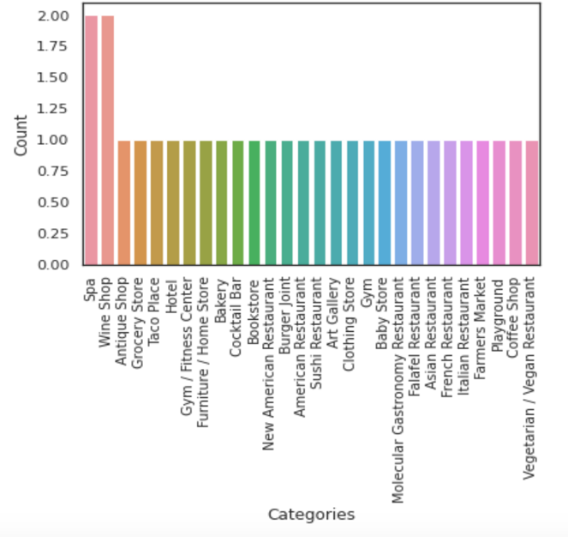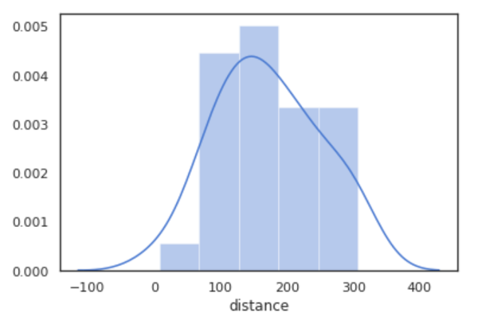

1. (b)

Figure 1 (a) Occurences of categories among the popular locations (b) Distribution of the distance between the popular locations and Eeco

Similarly, all the 30 prominent places near the restaurant were with 300 metres of distance, where 150 metres being the highest distance from Eeco as shown in Figure 1(b).

3**.1 Geo-spatial visualization of popular locations**

Folium maps were used to visualize the 30 popular places near Eeco as shown in the Figure 2. The Red dot in the below image denotes the Eeco and the blue dots represent the prominent places near Eeco. This gives us a wider visual representation of the how close these locations are to Eeco.

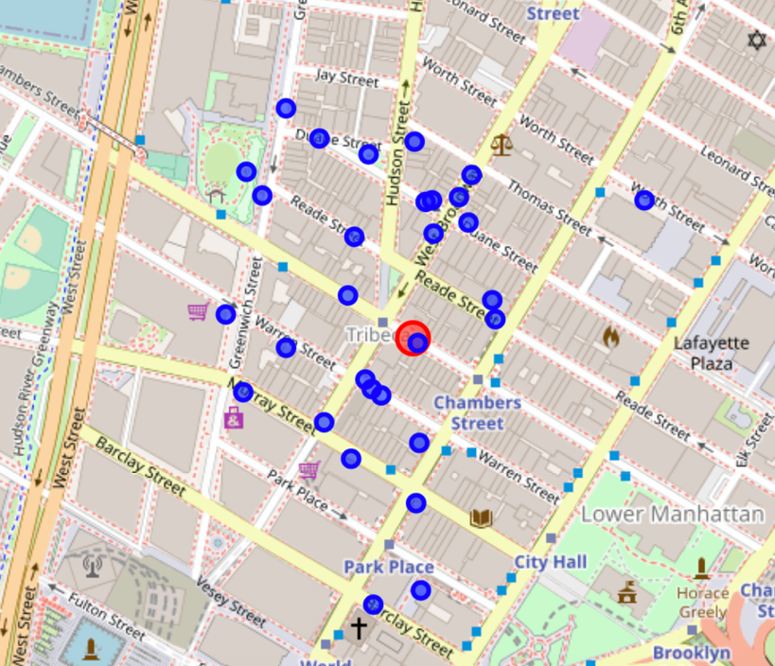

Figure 2. Geo-spatial visualization of the popular locations near Eeco

1. **KNN clustering**

A KNN clustering was performed among their 30 locations with a k values of 5 forming 5 different clusters based on their latitude and longitude locations as shown in the below Figure 3. The below Table 2, shows the statistics of each cluster groups, where cluster group 0 has 8 different locations with 7 unique categories and with an average rating of 8.72.

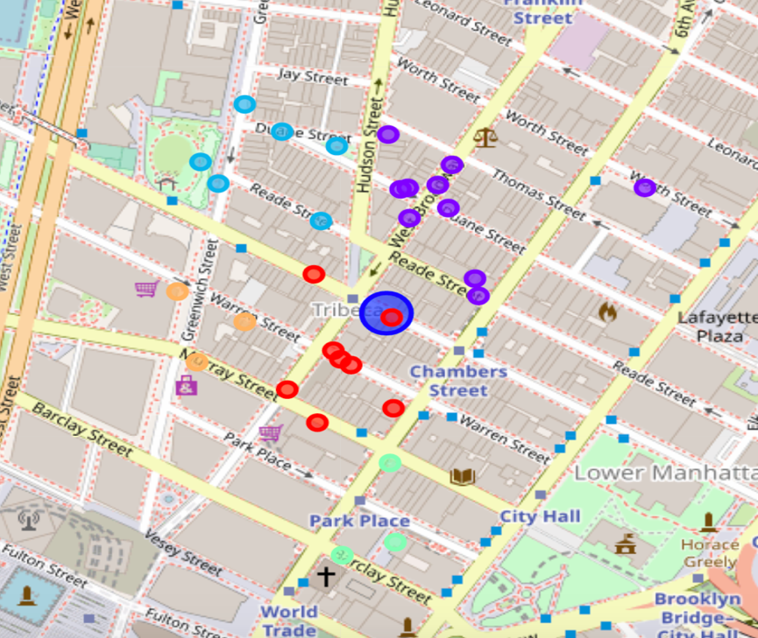

Figure 3. KNN(k=5) clustering of the popular places near Eeco

Table 2. Statistics of the Clusters before thresholding

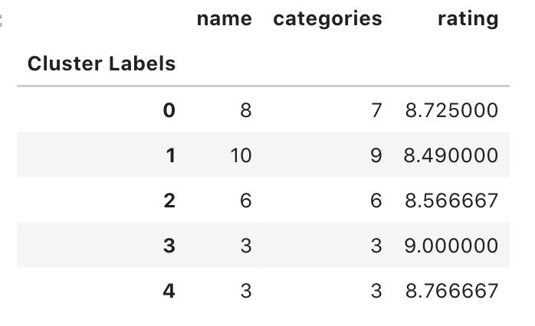

For each of the 30 locations, a threshold value was set at 8.5, only locations with rating greater than 8.5 were considered into analysis. After the removal of the locations which didn’t meet the criteria, the number of locations were narrowed down to 18 from 30 as shown in the below Table 3.

Table 3. Statistics of the Clusters after thresholding

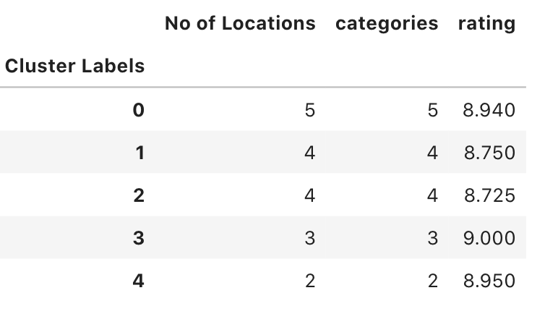

1. **Results**

Based on the ratings the ratio for each cluster i(0 to n) was calculated as shown in Eq. 1. Since the allotted money for the marketing strategy was 10000$ and each pamphlet costs around 2$, the number of pamphlets available is 500. The number of pamphlets allotted to each cluster is calculated using the formula shown in Eq. 2.

(1)

(2)

Table 4. No of posters assigned to cluster based on their rating and ratio

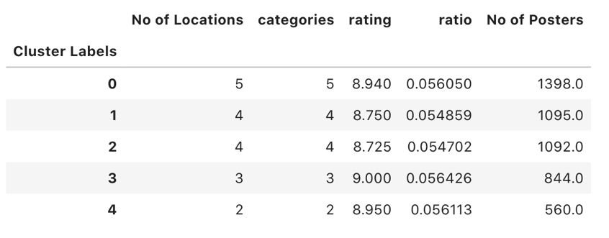

Based on the calculation from Eq. 1 & Eq. 2, the ratio and No of posters are calculated for the respective clusters. For cluster 0 around 1398 posters will be distributed for five different locations and similarly 1095, 1093, 844, 560 number of posters for cluster 1, 2, 3, 4 as shown in Table 4 and Figure 4.

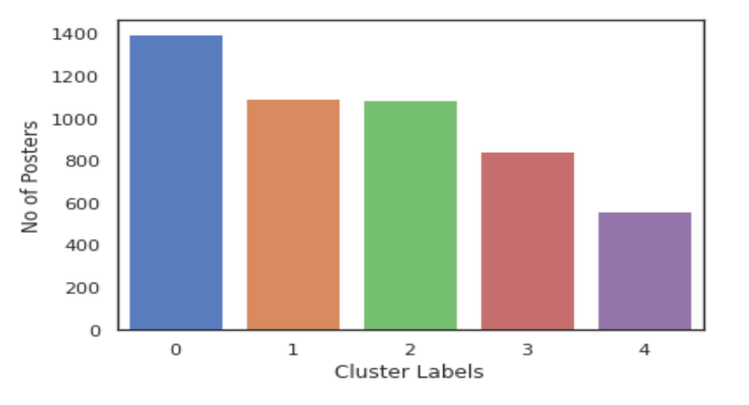

Figure 4. Number of Posters allotted to each Clusters

The below Figure 5, gives an idea of how many phamplets will be distributed to the respective category locations. The playground category will be the location where most of th ephamplets will be distributed based on our KNN(k=5) clustering model.

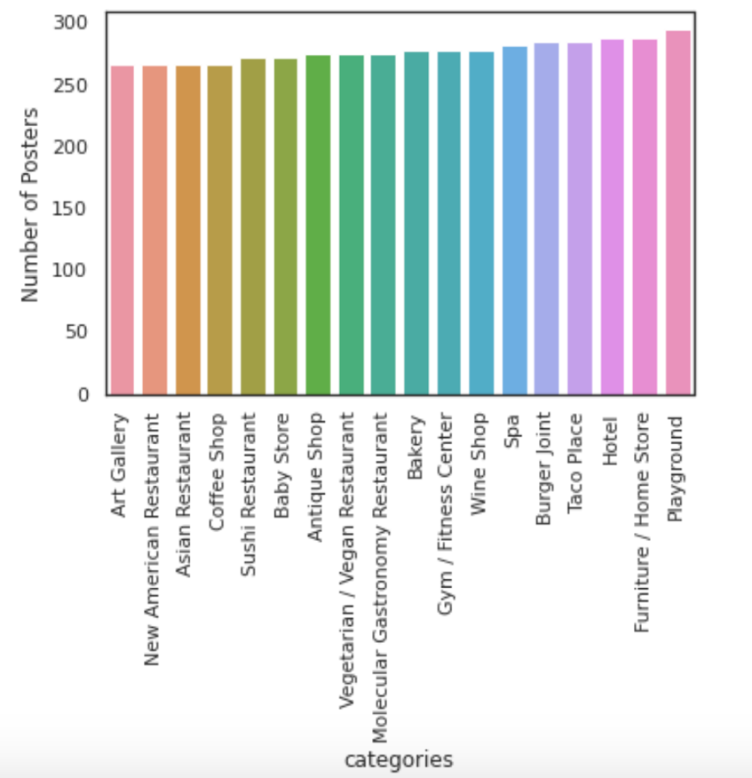

Figure 5. Number of Posters allotted to each Category

As shown the below Figure 6, the 18 locations surrounding Eeco(Large Blue circle), are the most prominent locations where the Eeco management could focus on distributing their pamphlets to have a maximum reach to the general public

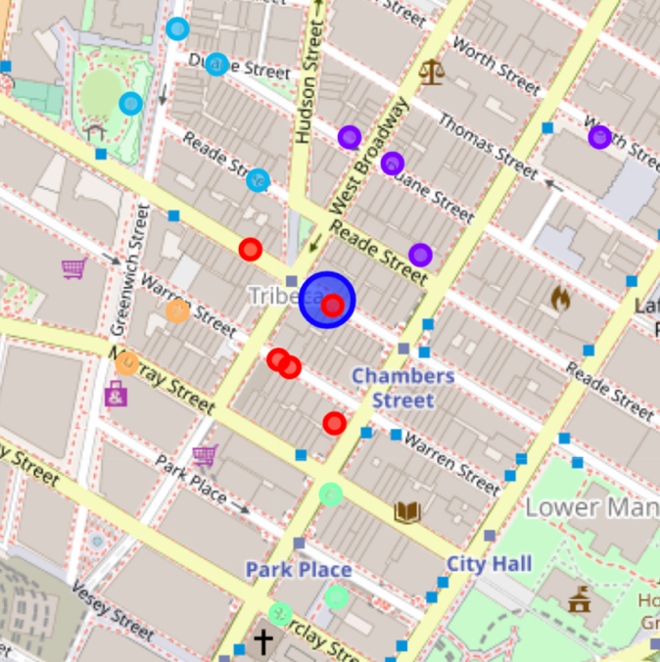

Figure 6. Popular areas near Eeco after thresholding

1. Future Directions

The approach mentioned in this study will help small scale business to identify the most prominent locations to market their products to have a better reach of audience and make sure their marketing strategies plays a vital role in their profit. This kind of an approach will help the establishment an upper hand over their competitors in gaining more attraction and audience and help them in building a brand value.